

**power property**

**power property**

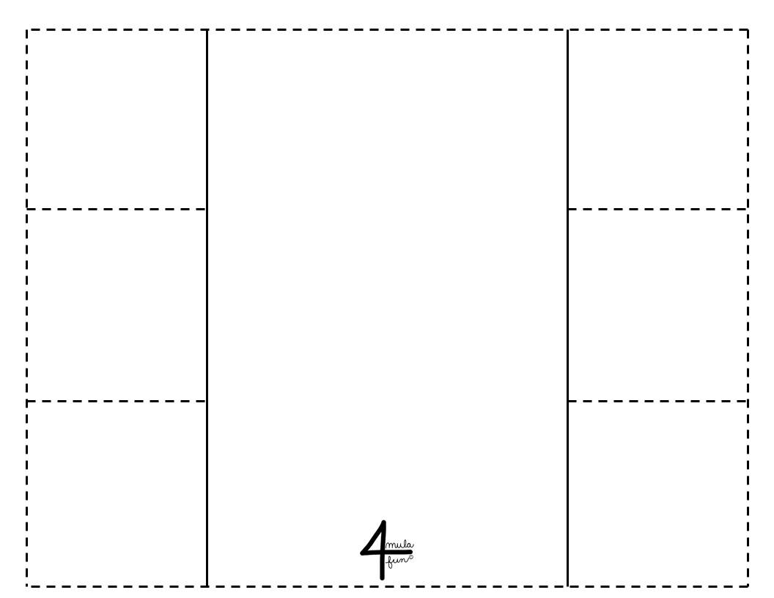

**quotient property**

**quotient property**

**product property**

**product property**





2logx =